**Name & Surname : Letlhogonolo Chabalala**

**Student No:ST10333694**

**Module code:PROG6212**

**POE PART 1**

**Step 1 : Documentation**

**Contract Monthly Claim System**

The Contract Monthly Claim System (CMCS) has been conceptualized to streamline the submission, verification, and approval of monthly claims for Independent Contractor (IC) lecturers. This prototype aims to provide a structured workflow that improves accuracy, increases transparency, and ensures a smooth interaction process for both lecturers and academic administrators.

**Design Rationale**

The proposed system is built around three essential user roles: Lecturer, Programme Coordinator, and Academic Manager. Lecturers are responsible for submitting claims along with the necessary supporting documents, while Coordinators act as the first line of review. Academic Managers then carry out the final approval of claims. This layered approach was chosen to promote accountability and prevent misuse of the process, while also reflecting a real-world chain of approval found in most academic institutions.

For the prototype interface, Windows Presentation Foundation (WPF) using .NET was selected. This technology is widely applied in professional software development, offering flexibility, scalability, and strong support for modern graphical interfaces. The decision was based on its ability to create visually appealing layouts while remaining intuitive for end-users. The design is simple and functional, focusing on clarity and easy navigation.

**Database Design**

The underlying database structure identifies five primary entities: Lecturer, Claim, ClaimItem, SupportingDocument, and Approval. These entities and their relationships ensure claims are stored in a consistent and organized way.

* A lecturer may submit multiple claims.
* Each claim can consist of several items (e.g., different classes or hours worked).
* Documents are linked to claims to provide supporting evidence.
* Every claim must undergo an approval process, beginning with the Programme Coordinator and ending with the Academic Manager.

This design enforces normalization, eliminates redundancy, and allows for easy traceability of claims from submission through to approval.

**User Interface Layout**

The graphical user interface (GUI) prototype includes a Welcome screen with options for navigating to the Lecturer, Coordinator, or Manager sections. Each role has a tailored view:

* Lecturer View – Allows users to capture working hours, calculate claim totals, upload supporting files, and track claim progress.
* Coordinator View – Displays a list of pending claims, where coordinators can either approve or reject submissions.
* Manager View – Provides a final approval dashboard, showing claims that have already been verified by coordinators.

The interface makes use of straightforward buttons, forms, and lists. At this stage, it functions only as a visual prototype without back-end logic, in line with the project requirements.

**Assumptions and Constraints**

Several assumptions were made during the planning stage. It is assumed that lecturers will have digital copies of their documents available for upload, and that Coordinators and Managers will review claims within five working days. Internet access is also assumed, as it supports the uploading and sharing of files.

Constraints include preventing duplicate claim submissions for the same period and ensuring that each lecturer’s monthly claim is uniquely identified. These rules help maintain system integrity and reliability.

**Conclusion**

In summary, the Part 1 prototype of the CMCS focuses on creating a clear structure for data storage and a simple, role-based user interface. By combining thoughtful database design with a practical front-end layout, the system provides a foundation that can later be developed into a fully functional claim management tool. This stage ensures that the groundworkhas been carefully considered before moving on to implementation in subsequent parts of the project.

**Step 2: UML Class Diagram**

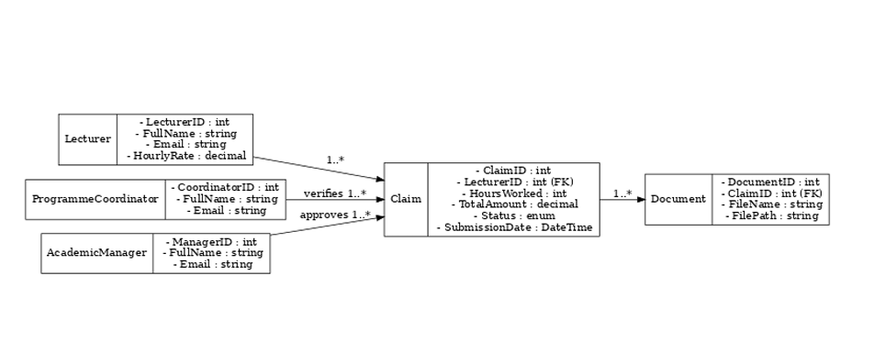

**Step 3 :Project Plan**

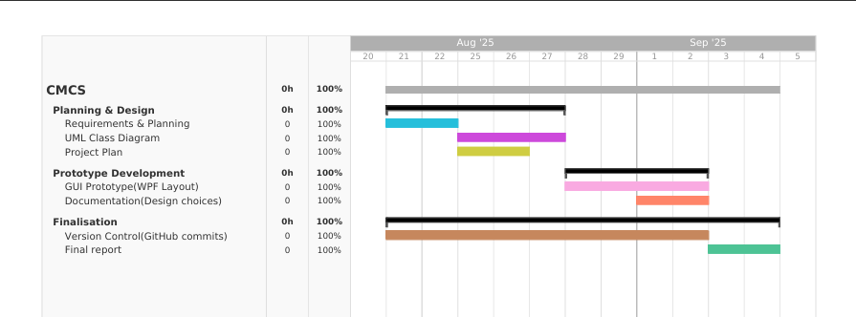

**Step 4 : GUI/UI Prototype**

**Welcome screen**

<Window x:Class="CMCS.MainWindow"

xmlns="http://schemas.microsoft.com/winfx/2006/xaml/presentation"

xmlns:x="http://schemas.microsoft.com/winfx/2006/xaml"

Title="CMCS - Contract Monthly Claim System" Height="460" Width="760">

<DockPanel LastChildFill="True">

<!-- Header -->

<Border DockPanel.Dock="Top" Height="64" Background="#2D2D30">

<Grid>

<Grid.ColumnDefinitions>

<ColumnDefinition Width="*" />

<ColumnDefinition Width="Auto" />

</Grid.ColumnDefinitions>

<StackPanel Orientation="Horizontal" VerticalAlignment="Center" Margin="16,0">

<TextBlock Text="📝 CMCS" FontSize="22" FontWeight="Bold" Foreground="{StaticResource AccentColor}" />

<TextBlock Text=" | Contract Monthly Claim System" FontSize="16" Foreground="White" VerticalAlignment="Center"/>

</StackPanel>

</Grid>

</Border>

<!-- Content -->

<Grid Background="{StaticResource PrimaryBackground}">

<StackPanel VerticalAlignment="Center" HorizontalAlignment="Center" Width="340">

<TextBlock Text="Welcome" FontSize="26" FontWeight="Bold" HorizontalAlignment="Center" Margin="0,0,0,18"/>

<TextBlock Text="Choose a portal to continue" Foreground="{StaticResource SubtleText}"

HorizontalAlignment="Center" Margin="0,0,0,22"/>

<Button Content="Lecturer Portal" Click="OpenLecturer"/>

<Button Content="Coordinator Portal" Click="OpenCoordinator"/>

<Button Content="Manager Portal" Click="OpenManager"/>

</StackPanel>

</Grid>

</DockPanel>

</Window>

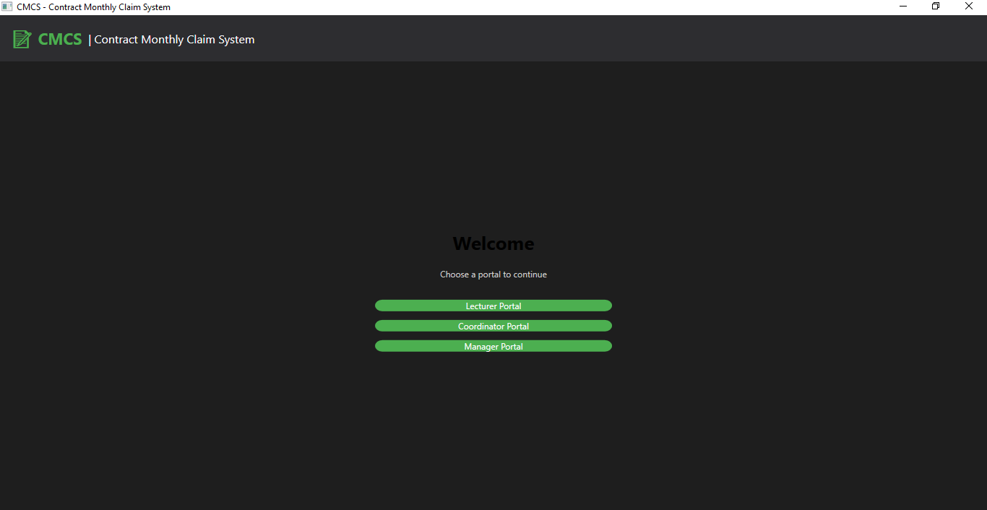

**Lecturer screen**

<Window x:Class="CMCS.Views.LecturerView"

xmlns="http://schemas.microsoft.com/winfx/2006/xaml/presentation"

xmlns:x="http://schemas.microsoft.com/winfx/2006/xaml"

Title="Lecturer Portal" Height="520" Width="820">

<DockPanel LastChildFill="True">

<!-- Header -->

<Border DockPanel.Dock="Top" Height="64" Background="#2D2D30">

<StackPanel Orientation="Horizontal" VerticalAlignment="Center" Margin="16,0">

<TextBlock Text="📝 CMCS" FontSize="22" FontWeight="Bold" Foreground="{StaticResource AccentColor}" />

<TextBlock Text=" | Lecturer Portal" FontSize="16" Foreground="White" VerticalAlignment="Center"/>

</StackPanel>

</Border>

<!-- Content -->

<Grid Background="{StaticResource PrimaryBackground}" Margin="18">

<Grid.ColumnDefinitions>

<ColumnDefinition Width="*" />

<ColumnDefinition Width="1.2*" />

</Grid.ColumnDefinitions>

<!-- Form Card -->

<Border Background="{StaticResource CardBackground}" CornerRadius="12" Padding="16" Margin="0,0,12,0">

<StackPanel>

<TextBlock Text="Submit New Claim" FontSize="20" FontWeight="Bold" Margin="0,0,0,10"/>

<TextBlock Text="Hours Worked" Foreground="{StaticResource SubtleText}" />

<TextBox />

<TextBlock Text="Hourly Rate" Foreground="{StaticResource SubtleText}" />

<TextBox />

<TextBlock Text="Description" Foreground="{StaticResource SubtleText}" />

<TextBox AcceptsReturn="True" Height="80" TextWrapping="Wrap"/>

<StackPanel Orientation="Horizontal" Margin="0,12,0,0">

<Button Content="Upload Supporting Document" />

<Button Content="Submit Claim" />

</StackPanel>

</StackPanel>

</Border>

<!-- Status Card -->

<Border Grid.Column="1" Background="{StaticResource CardBackground}" CornerRadius="12" Padding="16">

<StackPanel>

<TextBlock Text="Your Claim Status" FontSize="20" FontWeight="Bold" Margin="0,0,0,10"/>

<ListBox>

<ListBoxItem>Claim #1023 — Pending</ListBoxItem>

<ListBoxItem>Claim #1018 — Approved</ListBoxItem>

<ListBoxItem>Claim #1012 — Rejected</ListBoxItem>

</ListBox>

</StackPanel>

</Border>

</Grid>

</DockPanel>

</Window>

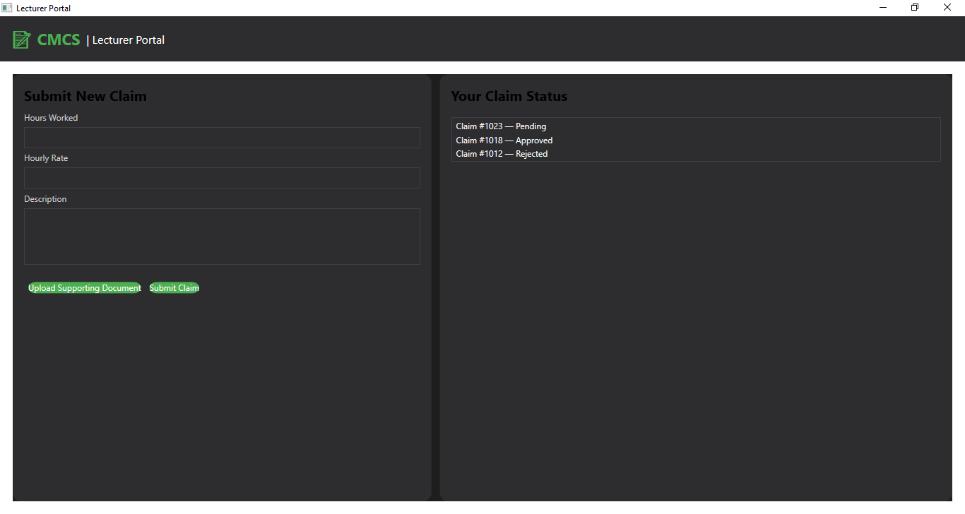

**Coordinator screen**

<Window x:Class="CMCS.Views.CoordinatorView"

xmlns="http://schemas.microsoft.com/winfx/2006/xaml/presentation"

xmlns:x="http://schemas.microsoft.com/winfx/2006/xaml"

Title="Coordinator Portal" Height="520" Width="820">

<DockPanel LastChildFill="True">

<!-- Header -->

<Border DockPanel.Dock="Top" Height="64" Background="#2D2D30">

<StackPanel Orientation="Horizontal" VerticalAlignment="Center" Margin="16,0">

<TextBlock Text="📝 CMCS" FontSize="22" FontWeight="Bold" Foreground="{StaticResource AccentColor}" />

<TextBlock Text=" | Coordinator Portal" FontSize="16" Foreground="White" VerticalAlignment="Center"/>

</StackPanel>

</Border>

<!-- Content -->

<Grid Background="{StaticResource PrimaryBackground}" Margin="18">

<Border Background="{StaticResource CardBackground}" CornerRadius="12" Padding="16">

<StackPanel>

<TextBlock Text="Coordinator Dashboard" FontSize="20" FontWeight="Bold" Margin="0,0,0,10"/>

<TextBlock Text="Incoming Claims" Foreground="{StaticResource SubtleText}" />

<ListBox Height="280">

<ListBoxItem>Claim #1041 — Awaiting Review — 12h @ R450</ListBoxItem>

<ListBoxItem>Claim #1040 — Awaiting Review — 8h @ R450</ListBoxItem>

<ListBoxItem>Claim #1038 — Revised — 10h @ R450</ListBoxItem>

</ListBox>

<StackPanel Orientation="Horizontal" HorizontalAlignment="Center" Margin="0,12,0,0">

<Button Content="Approve" Width="140"/>

<Button Content="Reject" Width="140"/>

</StackPanel>

</StackPanel>

</Border>

</Grid>

</DockPanel>

</Window>

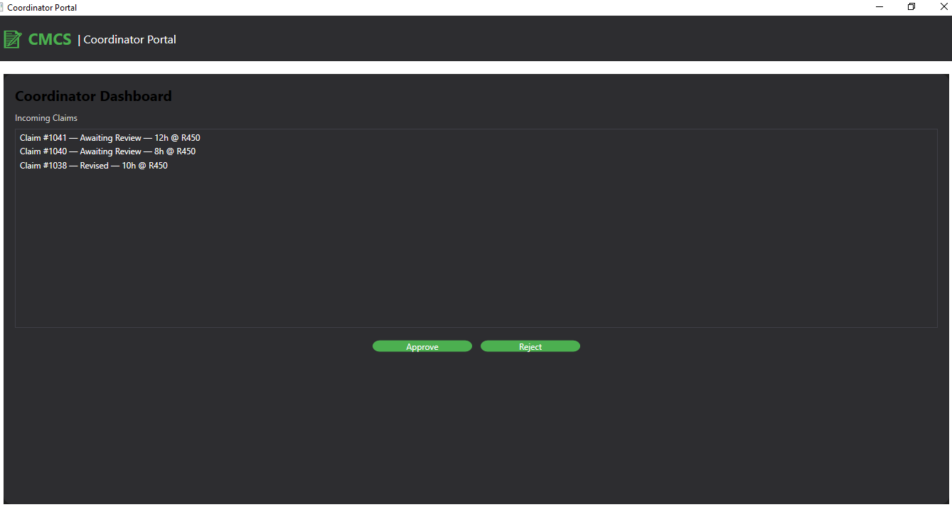

**Manager screen**

<Window x:Class="CMCS.Views.ManagerView"

xmlns="http://schemas.microsoft.com/winfx/2006/xaml/presentation"

xmlns:x="http://schemas.microsoft.com/winfx/2006/xaml"

Title="Manager Portal" Height="520" Width="820">

<DockPanel LastChildFill="True">

<!-- Header -->

<Border DockPanel.Dock="Top" Height="64" Background="#2D2D30">

<StackPanel Orientation="Horizontal" VerticalAlignment="Center" Margin="16,0">

<TextBlock Text="📝 CMCS" FontSize="22" FontWeight="Bold" Foreground="{StaticResource AccentColor}" />

<TextBlock Text=" | Manager Portal" FontSize="16" Foreground="White" VerticalAlignment="Center"/>

</StackPanel>

</Border>

<!-- Content -->

<Grid Background="{StaticResource PrimaryBackground}" Margin="18">

<Border Background="{StaticResource CardBackground}" CornerRadius="12" Padding="16">

<StackPanel>

<TextBlock Text="Manager Approval Dashboard" FontSize="20" FontWeight="Bold" Margin="0,0,0,10"/>

<TextBlock Text="Coordinator-Approved Claims" Foreground="{StaticResource SubtleText}" />

<ListBox Height="280">

<ListBoxItem>Claim #1037 — Coordinator Approved — 15h — R6,750</ListBoxItem>

<ListBoxItem>Claim #1034 — Coordinator Approved — 11h — R4,950</ListBoxItem>

</ListBox>

<StackPanel Orientation="Horizontal" HorizontalAlignment="Center" Margin="0,12,0,0">

<Button Content="Final Approve" Width="160"/>

<Button Content="Final Reject" Width="160"/>

</StackPanel>

</StackPanel>

</Border>

</Grid>

</DockPanel>

</Window>

